Since 2009, New Day for Children, based in Alamo, California, has worked to provide hope and help to families of sex trafficked children here in the United States. Working in collaboration with others, like the Rotary Club of Lafayette, New Day for Children makes possible services such as: safe housing, therapy that specializes in sexual trauma and PTSD, education, horse therapy, medical and dental needs, and much more. We work with law enforcement, other faith based/community organizations and families to support the needs of American girls, ages 10 to 18, suffering from the trauma of sex trafficking.

New Day has had the honor of supporting 89 girls, making it possible for them to get the help they need, in a safe environment, for as long as they need. Approximately two-thirds of our girls are from California; many of them from, and/or, trafficked in the Bay Area. In 2019, Swing to Freedom has provided support to 12 minor girls and who have been rescued from sex trafficking. This support gives the gift of another birthday as the average life expectancy of a trafficked person is 7 years. Today, New Day for Children is supporting 9 girls at our main collaborative boarding school which is located in Northern California. Six of these girls are from California, the others are from Michigan, Texas and Tennessee. We also provide support to older girls in transition around the country.
The Rotary Club of Lafayette’s Swing to Freedom funding has truly saved lives. “Gabbi” was trafficked in the Bay Area for 10 years by the very people who were to love and protect her; she has no memories of not being bought and sold. When she came to New Day in January of 2018, she had bed bugs, scabies and a chronic infection. Because of the funding we received from Swing to Freedom, we were able to safely house her and get her the therapy and medical treatment she needed. She even sports a new set of braces. In spring of 2019 we were able to fly her back and forth for home visits to get to know her new family in another state. They have since obtained legal guardianship of her – New Day was able to pay her attorney fees as well because of Swing to Freedom! On October 17, “Gabbi” underwent 6+ hours of surgery to repair the damage done to her. She is resting comfortably and recovering in her new home for the next couple of weeks.
Swing to Freedom has also provided:

- MUCH needed medical and dental care.
  - The girls often have physical damage and/or STDs that need to be addressed
  - Just last Thursday one of our girls, who is now in Illinois, had 6 hours of surgery to correct the damage done to her, which I am happy to report was very successful! She has about an 8-week recovery in front of her.
- Tutoring for school
- Weekly therapy
- Two equine therapy camps
- Life skills development
- Clothing and hygiene supplies
- Fun activities – including a few days a beach house in Santa Cruz
- New Day has been able to improve and expand options for girls in transition. Airfare for college and trade school tours, tours of other programs for trafficking survivors over 18, and home visits. Counseling, extra school fees, books, and incidentals as well.

The New Day for Children model is highly scalable so our goal in 2020 is to expand our collaborative relationships to several states SO THAT we can support more rescued girls at a time.
- Sarah's Home in Colorado
- Solace House - due to open in Idaho in early 2020
- Looking in Nevada and Texas
- We are considering a program for boys as well at this time

Since 2009, New Day for Children has helped families of trafficked American girls get the restorative care and education they need. Partnering with residential boarding schools, we take a multi-faceted approach to meet the unique needs of each girl rescued, combining shelter, education, and therapy to help them rebuild their lives. Our goal is to restore their stolen childhoods, giving them a safe, loving, and hope-filled place to flourish and, in time, learn to lead happy, productive lives.
The United States Justice Department reports that roughly 300,000 American minors are at risk of being sexually trafficked in our country this year. It is the 2nd fastest growing crime industry in America. The Bay Area is a main trafficking hub in the country for children caught in Commercial Sexual Exploitation (CSE), and the numbers are growing. In the US, CSE children have a 7-year life expectancy. In many instances, CSE children have nowhere to turn once they've been rescued. New Day works closely with the FBI, Homeland Security, law enforcement and families across the country to restore girls victimized in this way.
Human trafficking is the 2nd fastest growing criminal industry in the United States.
Tisha,
A New Day Girl’s Story
I’m the daughter of really smart parents. My dad was a doctoral candidate at UC Berkeley, and my mom worked at the university too. Some boy started saying he loved me and that he had big plans for us. Before I knew it, he was selling me for sex to boys and men throughout the East Bay. I had been beat up pretty badly and never wanted to see this guy again, but as I began to settle in and heal I felt like maybe he really did love me! It took a long time for me to realize how badly I had been used; the teachers, therapists and the horses got me through all that.
A Homeland Security Statistic.
New Day is funded by organizations and individuals, like you, who want to help bring healing and closure to these girl's living nightmares. Take action and be part of transforming a girl’s life!

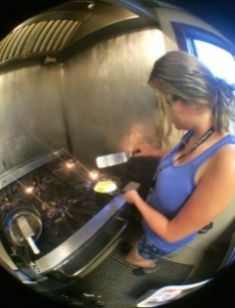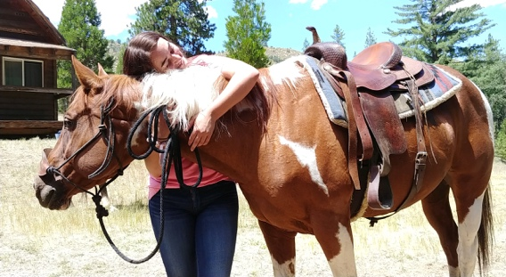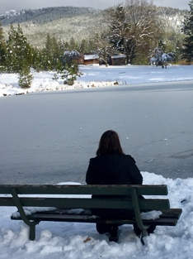

Angelina, A New Day Girl’s Story
I was 10 when my dad in Concord started selling me for sex to his friends right from my own bedroom. This was so awful and painful that I moved out and lived on the street. Living on the street in Concord wasn’t any better, and I was beat up a lot and abused. Finally when I was 13, my mom got custody of me and we started going to church. A youth pastor at the church contacted New Day and arranged for me to go to the school. I’m doing well in school and putting the pieces back together!

I just want to be normal. I don’t really even know what normal is, but I know it’s not what I’ve been through - a New Day Girl

